**Report about conducted load test**

**Date:** 24/08/2022

**Author:** Vladyslav Kliucharov

**Application:** BlogEngine.NET version 3.2

**Environment:** Test Environment VirtualBox (Version 6.1.34 r150636 (Qt5.6.2))

**Test Environment configuration (RAM, CPU etc.):**

|  |  |
| --- | --- |
| **Processor** | 11th Gen Intel(R) Core (TM) i7-1185G7 @ 3.00GHz 3.00 GHz (4 core) |
| **RAM** | 4 GB |
| **Hard Disk** | 60 GB |
| **Operating System** | Windows 10 Enterprise (21H2) |

1. **Why such testing was conducted:**

The report is included two methods of testing:

1. Smoke testing - was conducted to verification that the crucial functions of a program can be run and executed in the main workflow

2. Capacity Testing - was conducted to define the number of users that the application a given system will support and still meet performance goals

3. Stress testing - was conducted to define error handling capabilities under extremely heavy load conditions and to ensure that software doesn’t crash under crunch situations.

4. Load testing - was conducted to define how the application behaves during normal loads

1. **Test script description:**

The features to be tested have been logically grouped to be covered by 3 threads of users "Admin script", "Editor script" and "Anonymous script". These scenarios were combined in one script followed by load requirement analysis for the modules. The below table captures the features covered by each script. The implement probabilities usage was divided by percentages for all threads (shown below tables):

|  |  |
| --- | --- |
| **Admin script** | **Editor script** |
|  |  |

|  |  |  |
| --- | --- | --- |
|  | **Anonymous script** |  |
|  |  |  |

Scenario to implement probabilities usage:

|  |  |
| --- | --- |
| 1. Home Page: 15%  2. Open Random Date: 10%  3. Open Predefined Date: 30%  4. Search by Name: 30%  5. Open Large Calendar: 10%  6. Open Contacts: 5% | 1. Open Random page (yes/no): 50% / 50%  2. Open post (yes/no): 80% / 20%  3. Random or First (yes/no): 65% / 35%  4. Comment (yes/no): 20% / 80% |

1. **Tests:**  
   **Test run preconditions:**

* CSV file with Random dates
* Warmup script was running before each test run
* Before each new test script run, the webserver was reloaded, the test executed in NON-GUI mode
* Monitoring key performance indicator for the tests:

**Throughput (Max), Error rate, Response time (Average), Response time (Median), 90th Percentile (Mean), 95th Percentile (Mean)**

* From 3 runs in ”Task7” were defined the comfort zone was defined as 45 users
* For the low load testing the KPI for the test was taken from ”Task7” and user quantity were defined as 22

Scenarios model for capacity testing

|  |  |  |  |  |  |
| --- | --- | --- | --- | --- | --- |
| **Thread Group** | **Maximum number of simultaneous users** | **Ramp-Up period** | **Test duration** | **Probabilities usage** | **Number of posts quantity** |
| Thread Group (Admin users) | 2 | 200 | 850 (sec.) | Pre-Defined | 1000 |
| Thread Group (Editor users) | 10 | 100 | 850 (sec.) | Pre-Defined | 1000 |
| Thread Group (Anonymous users) | 88 | 800 | 850 (sec.) | Pre-Defined | 1000 |

Scenarios model for stress testing

|  |  |  |  |  |  |
| --- | --- | --- | --- | --- | --- |
| **Thread Group** | **Maximum number of simultaneous users** | **Ramp-Up period** | **Test duration** | **Probabilities usage** | **Number of posts quantity** |
| Thread Group (Admin users) | 2 | 2 | 650 (sec.) | Pre-Defined | 1000 |
| Thread Group (Editor users) | 10 | 10 | 650 (sec.) | Pre-Defined | 1000 |
| Thread Group (Anonymous users) | 88 | 88 | 650 (sec.) | Pre-Defined | 1000 |

Scenarios model for load testing

|  |  |  |  |  |  |
| --- | --- | --- | --- | --- | --- |
| **Thread Group** | **Maximum number of simultaneous users** | **Ramp-Up period** | **Test duration** | **Probabilities usage** | **Number of posts quantity** |
| Thread Group (Admin users) | 2 | 20 | 850 (sec.) | Pre-Defined | 1000 |
| Thread Group (Editor users) | 10 | 100 | 850 (sec.) | Pre-Defined | 1000 |
| Thread Group (Anonymous users) | 25 | 250 | 850 (sec.) | Pre-Defined | 1000 |

1. **Short summary on conducted tests:**

Virtual users cannot create or delete users, and they are unable to add a comment to post

1. **Detailed test results:**

‘Task 11’ script was running 1 time, according to the issue during migration of test data to new DB, the script was not able to create or delete users, and the virtual user was unable to add a comment to posts and edit post

**Test Run #1**

|  |  |  |
| --- | --- | --- |
| Response Code | Transaction | Error count |
| 404 | Transaction Controller (Delete User)  Transaction Controller (Save Post) | 157  578 |

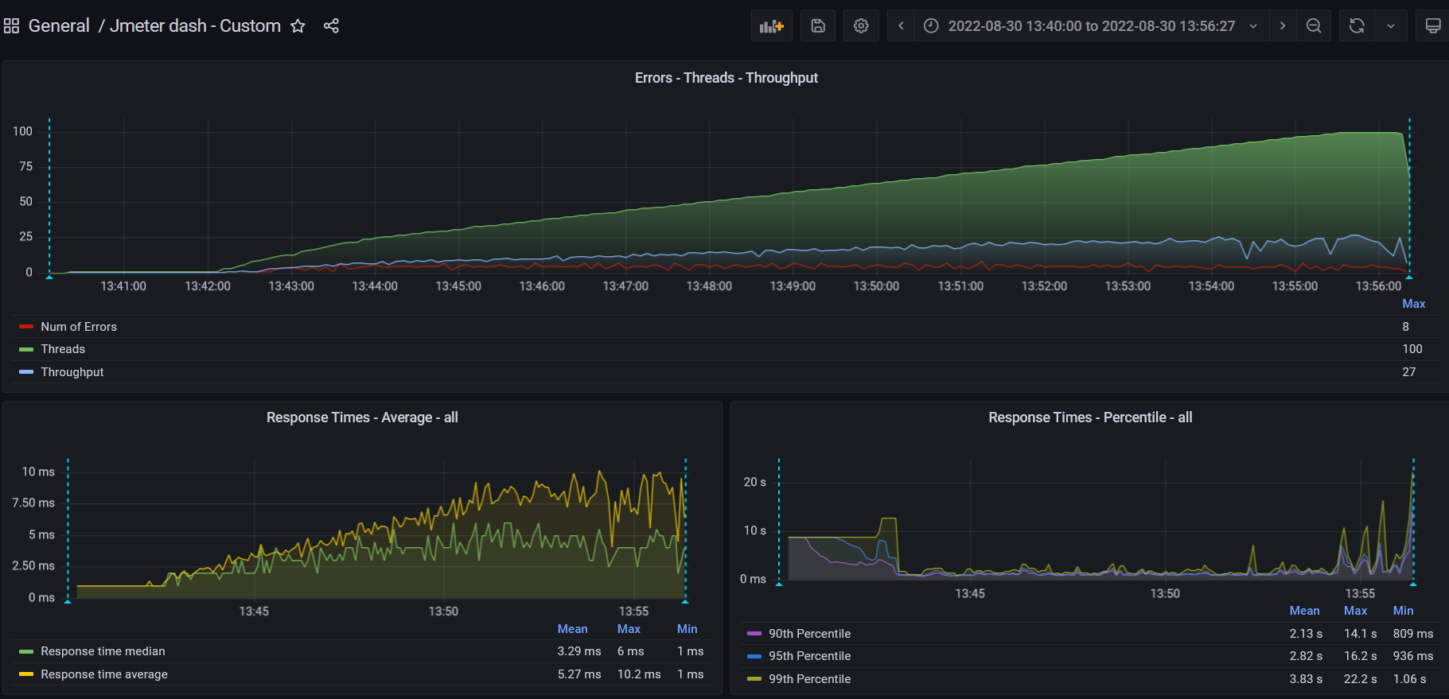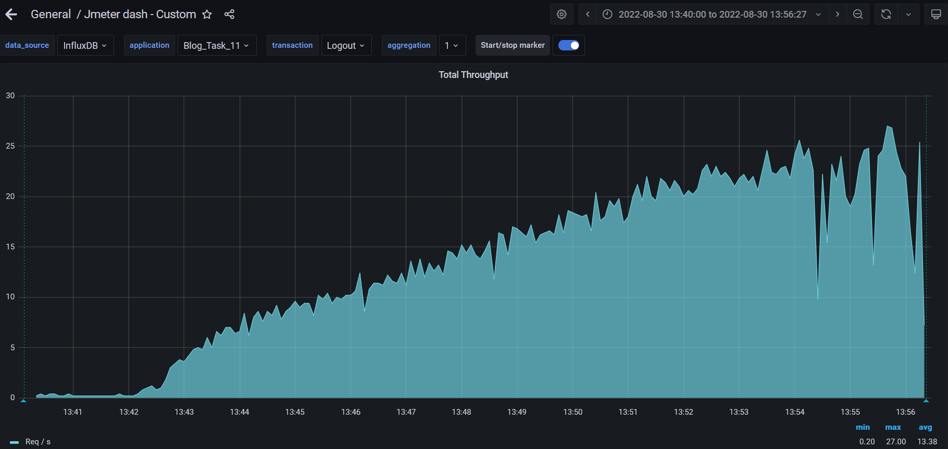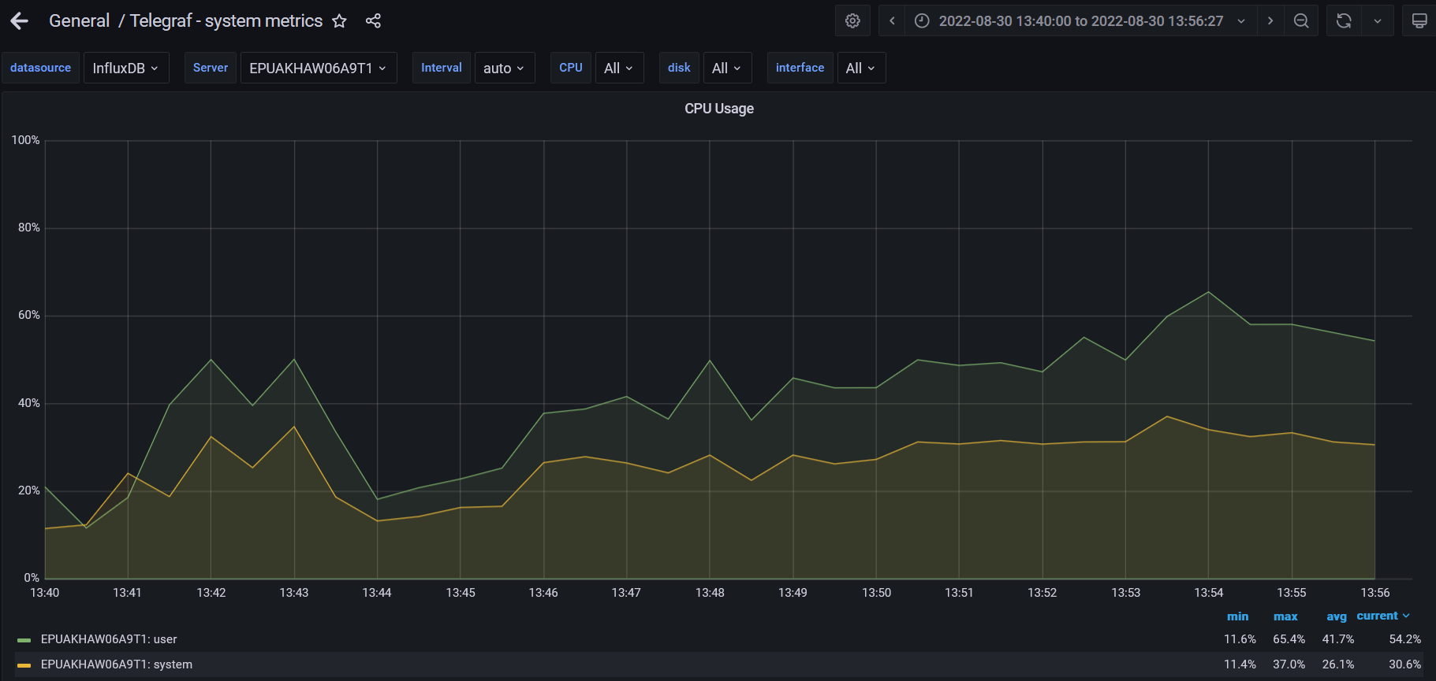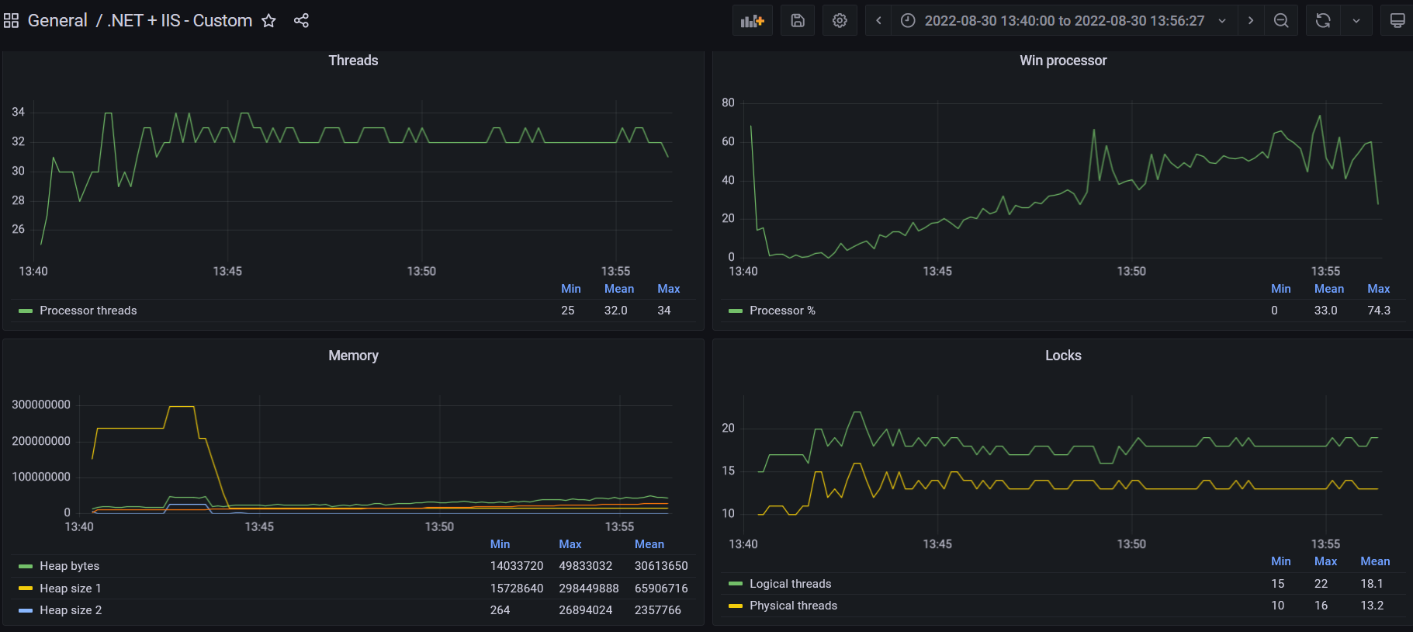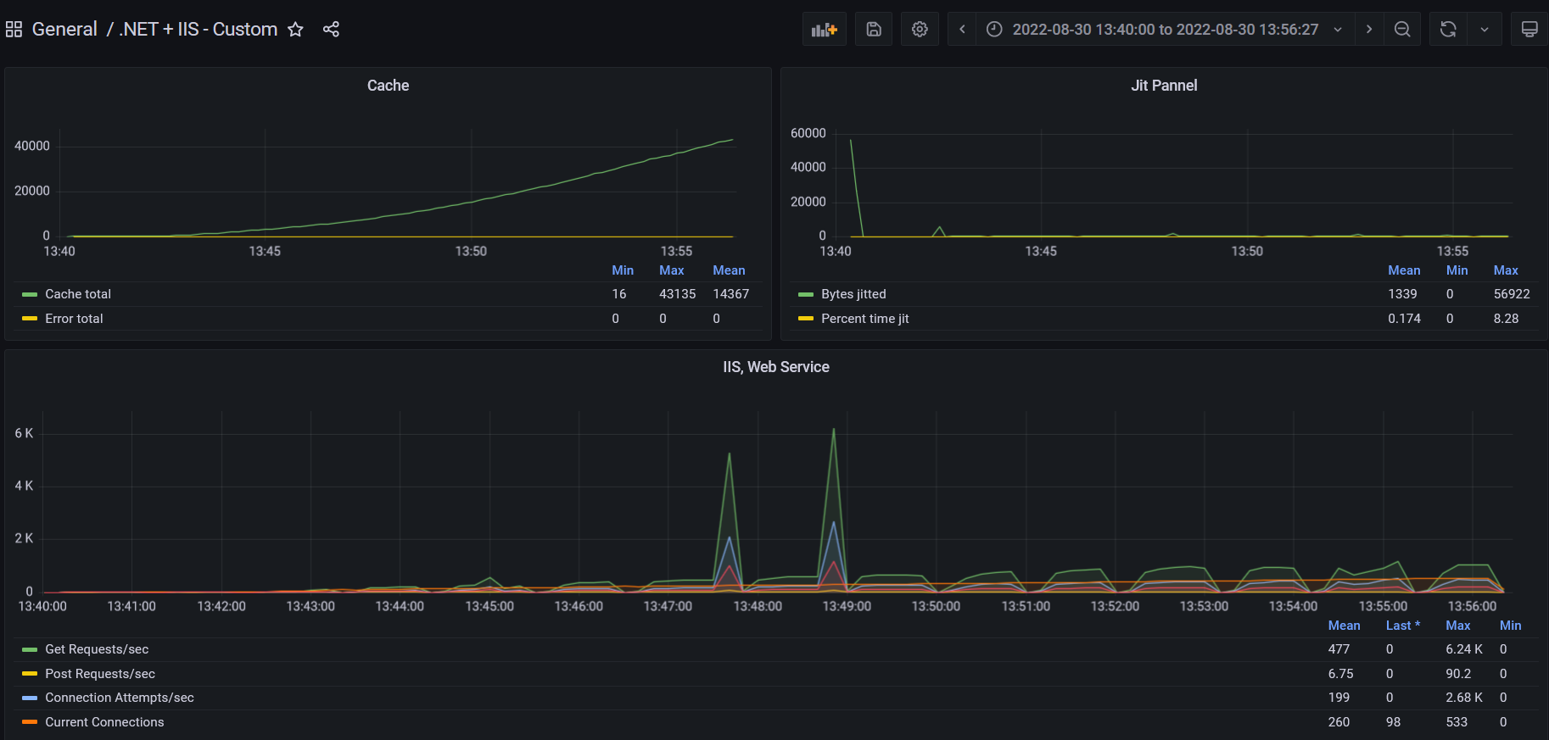

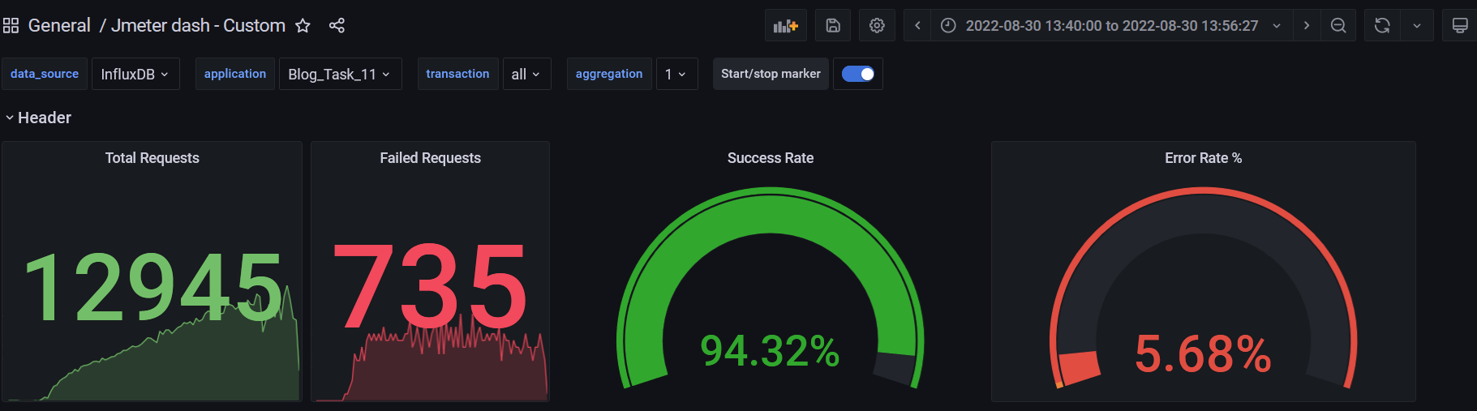

1. **Conclusion:**

The application worked unstably. The issue appeared during the migration of test data to the DB. The test was running 1 time, and in analyzing phase was found that adding and deletion of users by the script and adding comments to posts weren't executed, the received result cant show valid results. The attempts to resolve the issue by changing DB storage not helped (was tested with "MySQL" and "SQL lite")